20K-0409 Mukand

DEVOPS ASSIGNMENT # 1 roll no:20k-0409

**Scenario:**

You will be creating a website using HTML / JavaScript / CSS. The website will have the following:

• Home Page: Displaying a small intro about yourself.

• Projects: List all of your projects which can be filtered by typing technology (C# / Java / Node.js etc.) in a textbox

• Education: Page which shows all the courses that you have studied in since 9th grade.

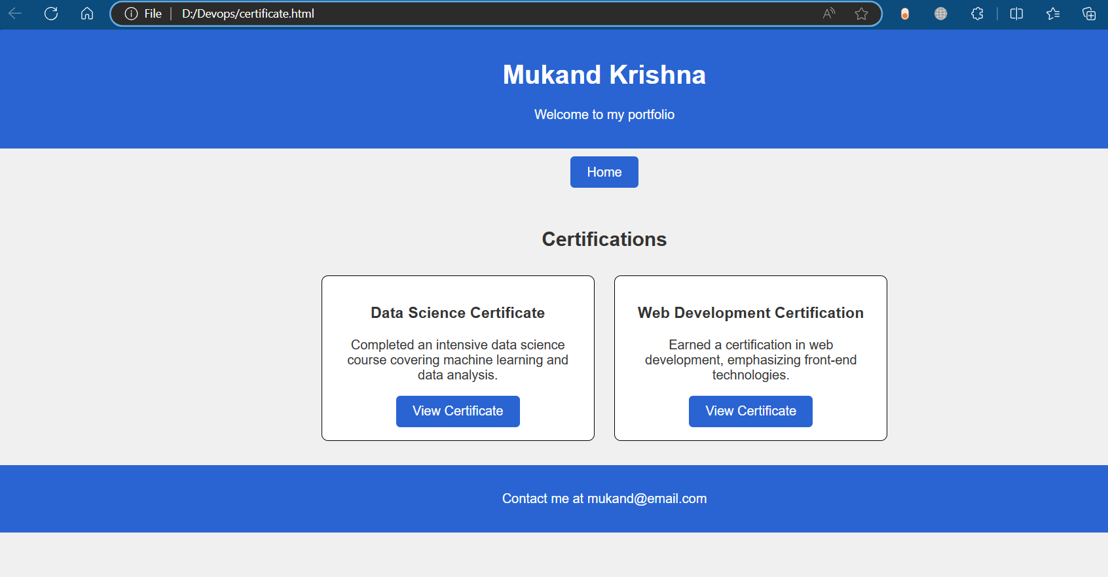

**TASK # 1**

**First Made repository on Github:**

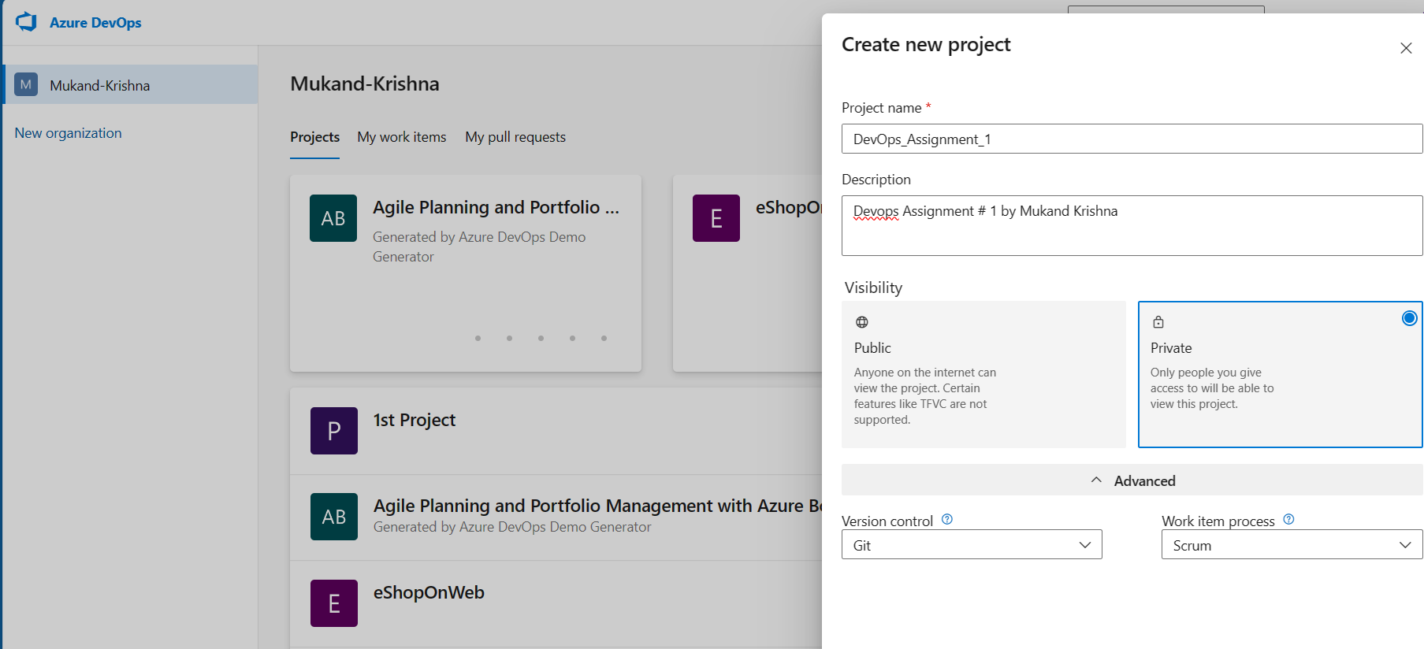

**Created Task # 1**:

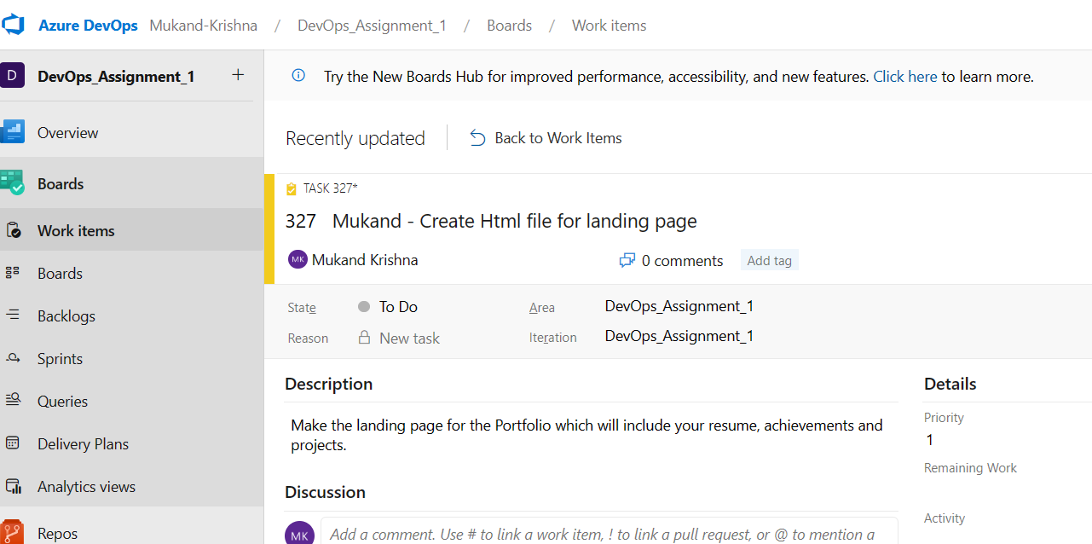

**Created Task # 2**:

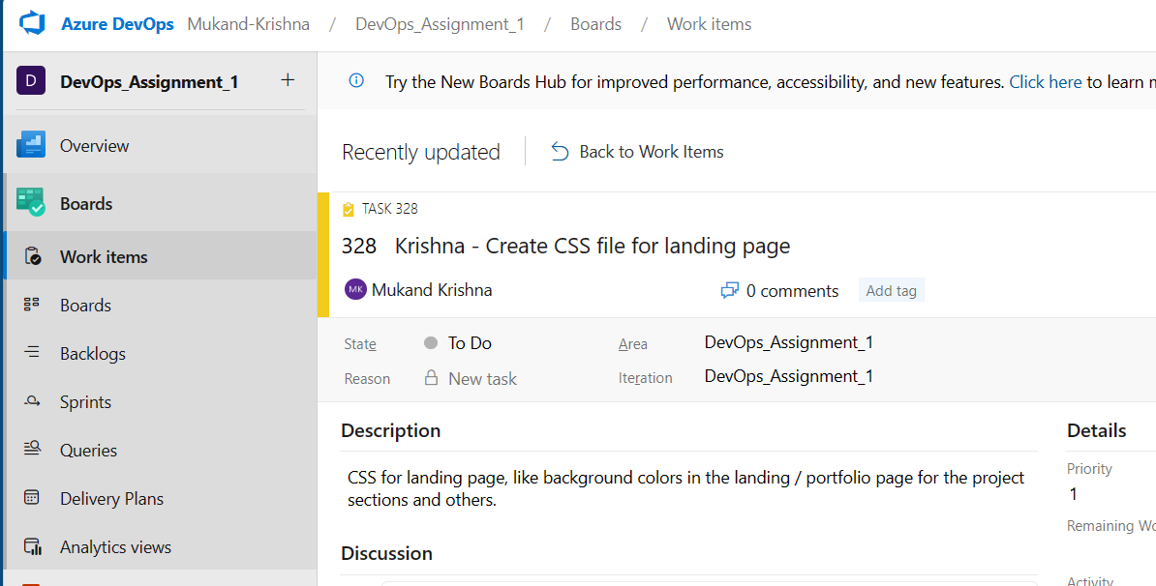

**Linked with HTML File.**

**Some Modifications by adding some tasks, Product backlogs, and 1 Feature.**

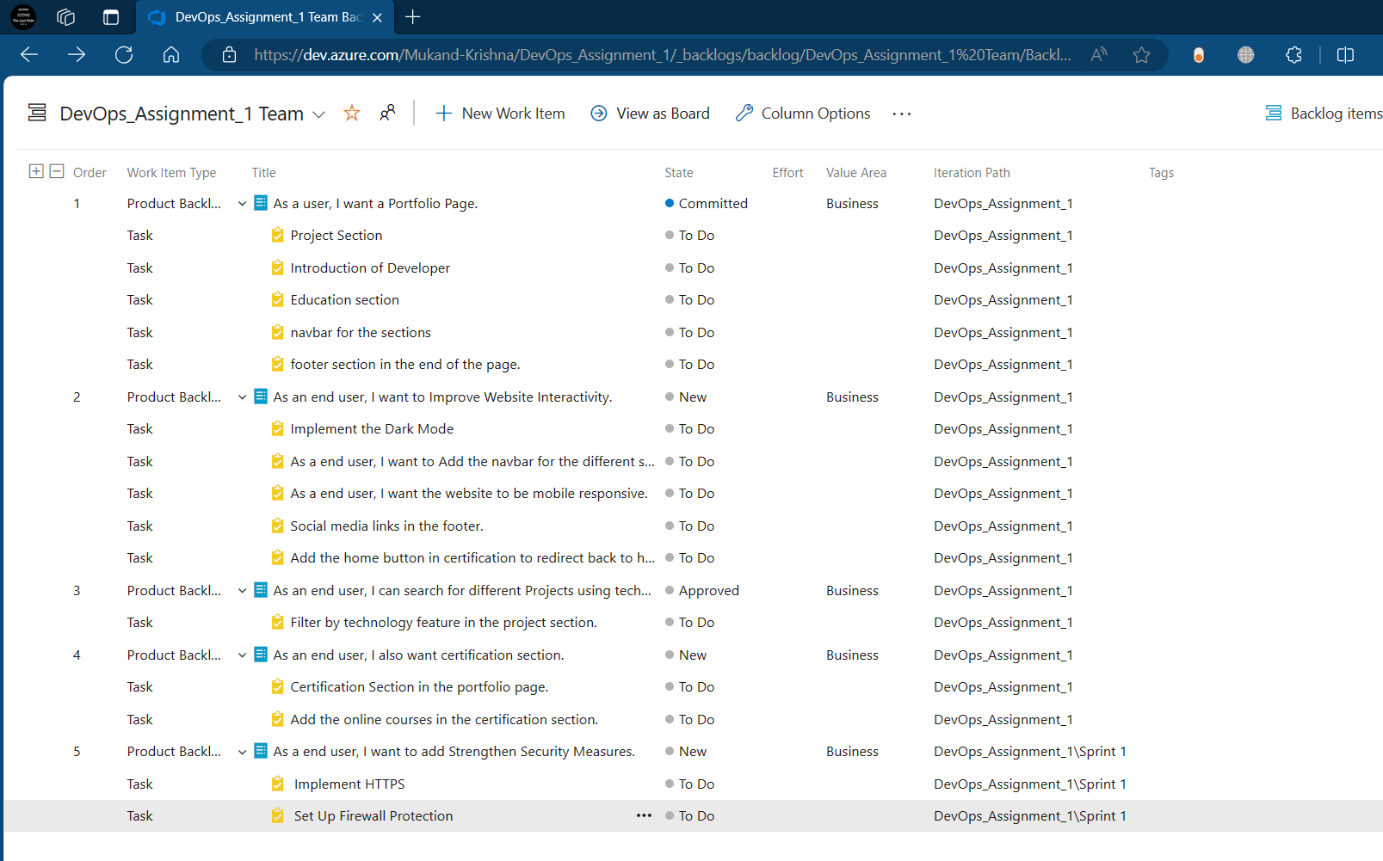

**TASK # 2**

**First Made repository on Github:**

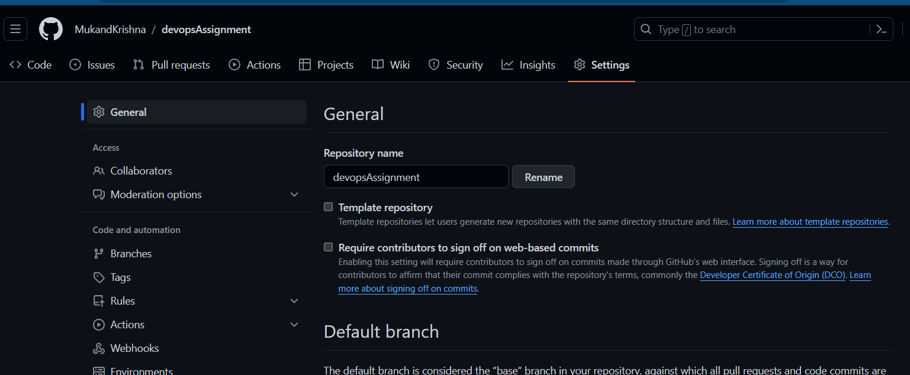

**Using Commands in VS code**:

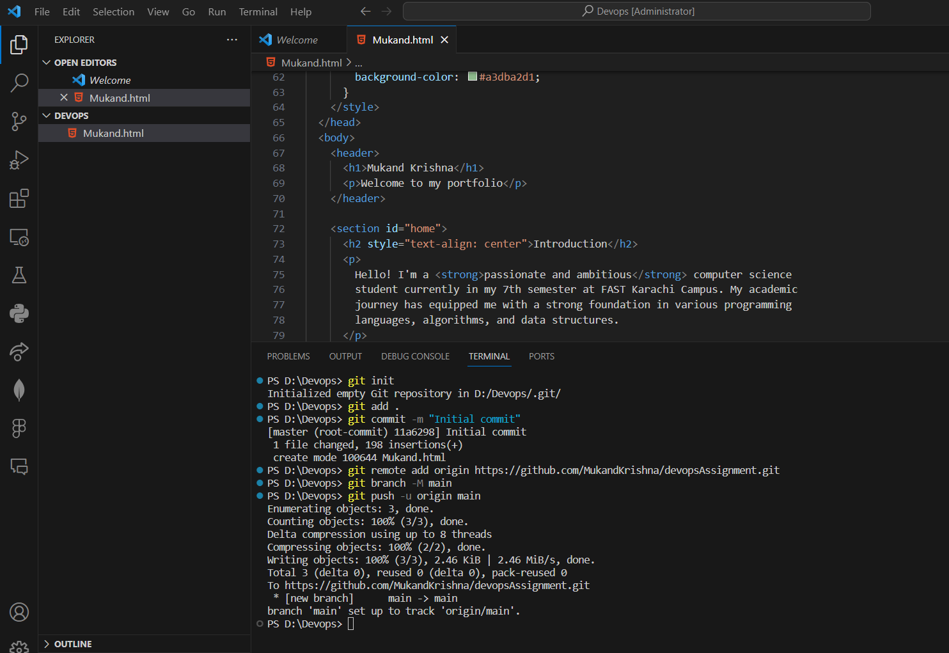

**WEBSITE Pushed to Github Repository**

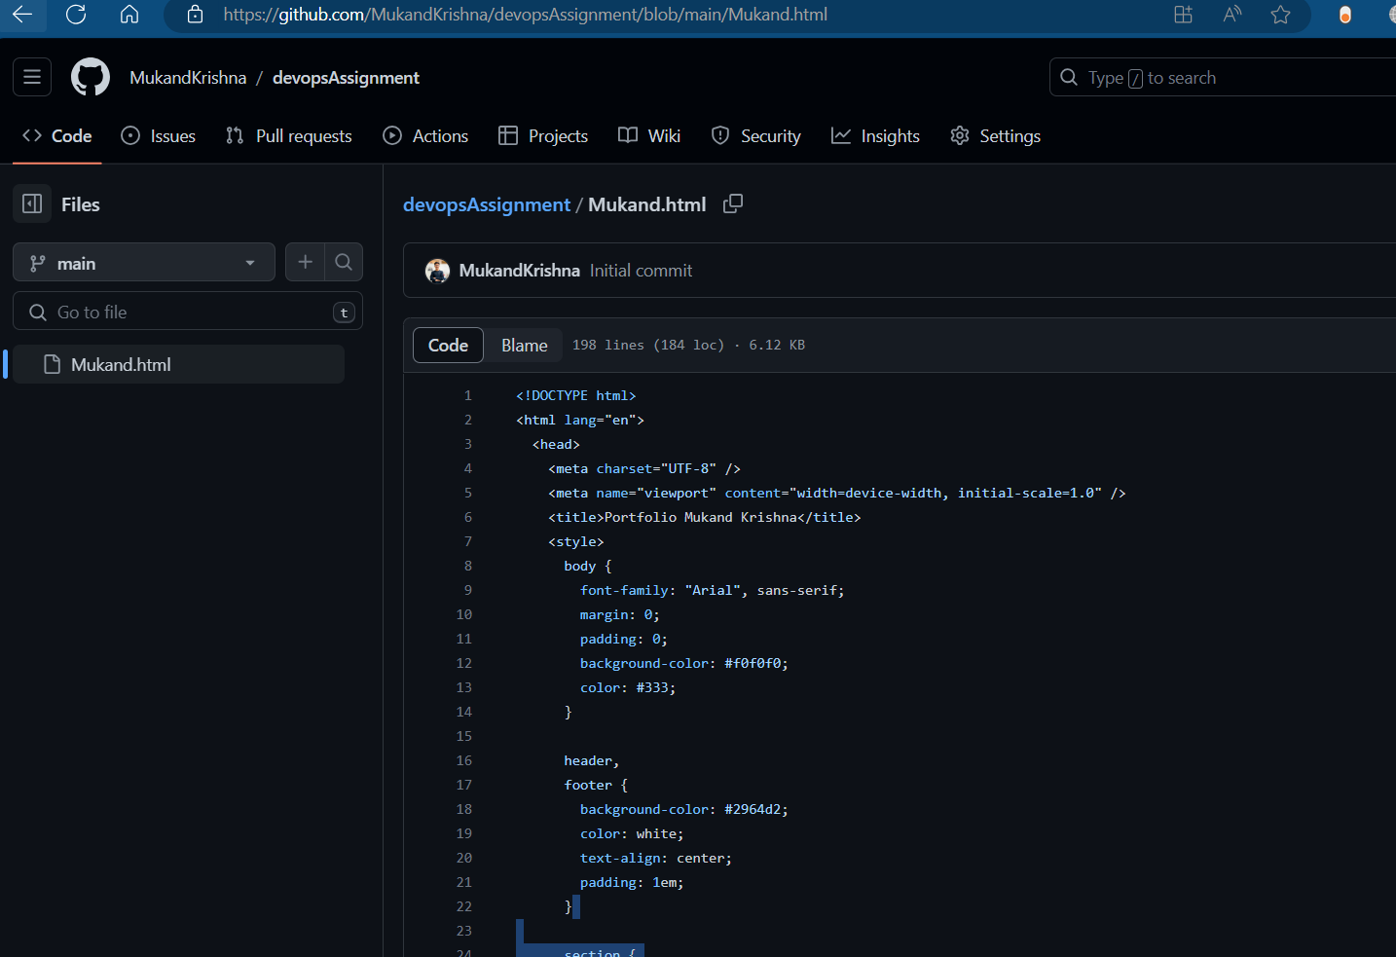

**TASK # 3**

**Pushing certificate.html code to repo:**

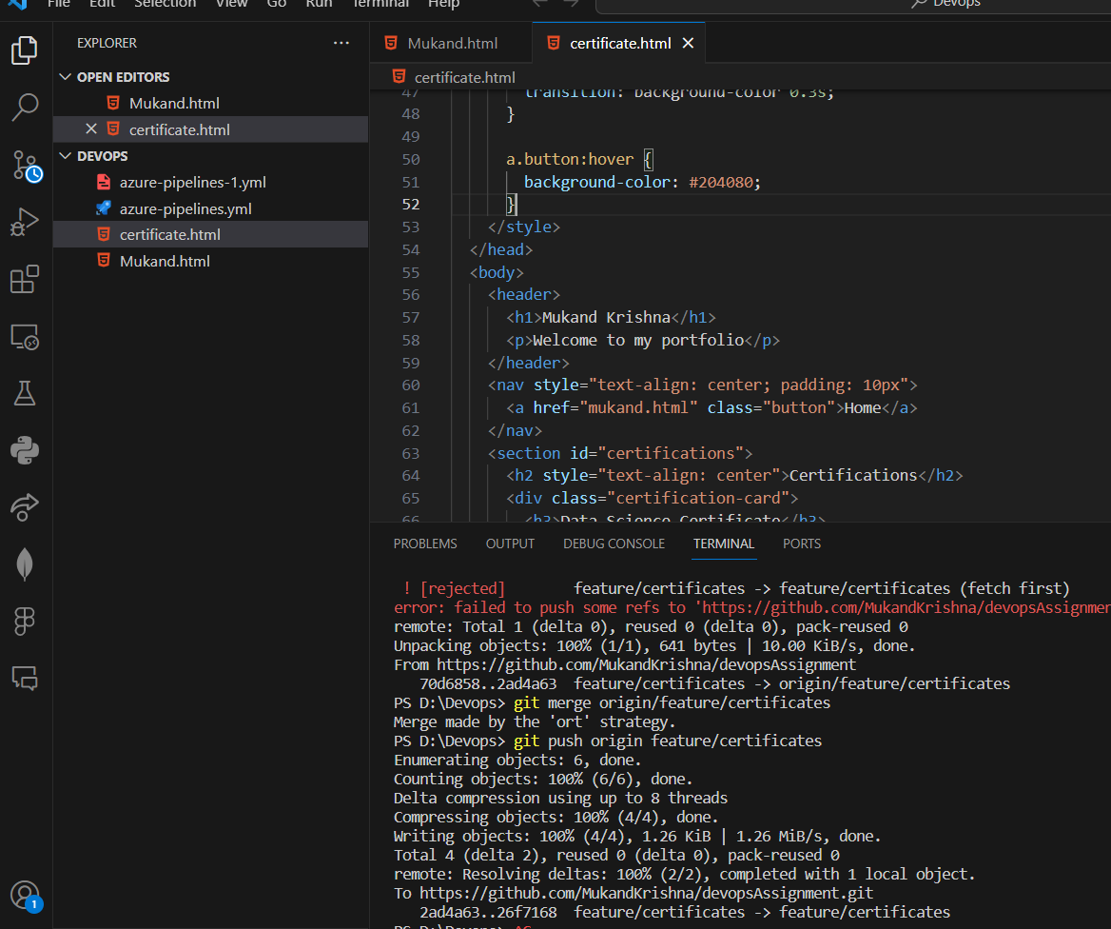

**TASK # 4**

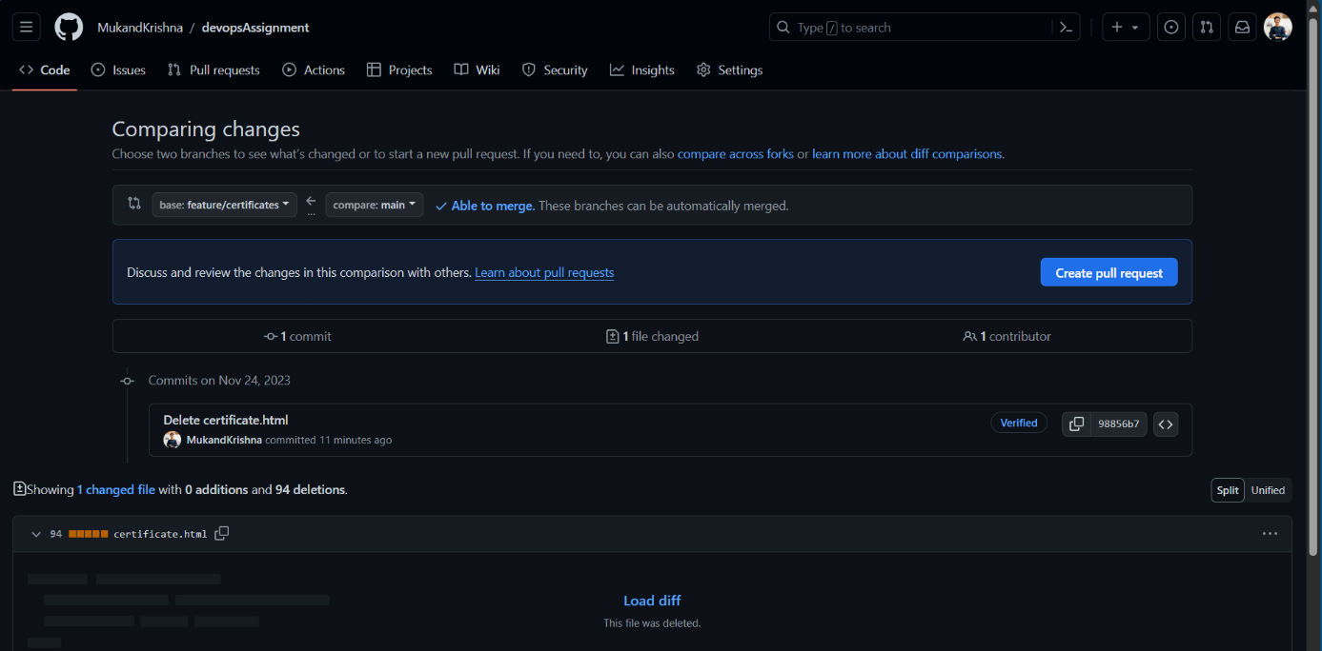

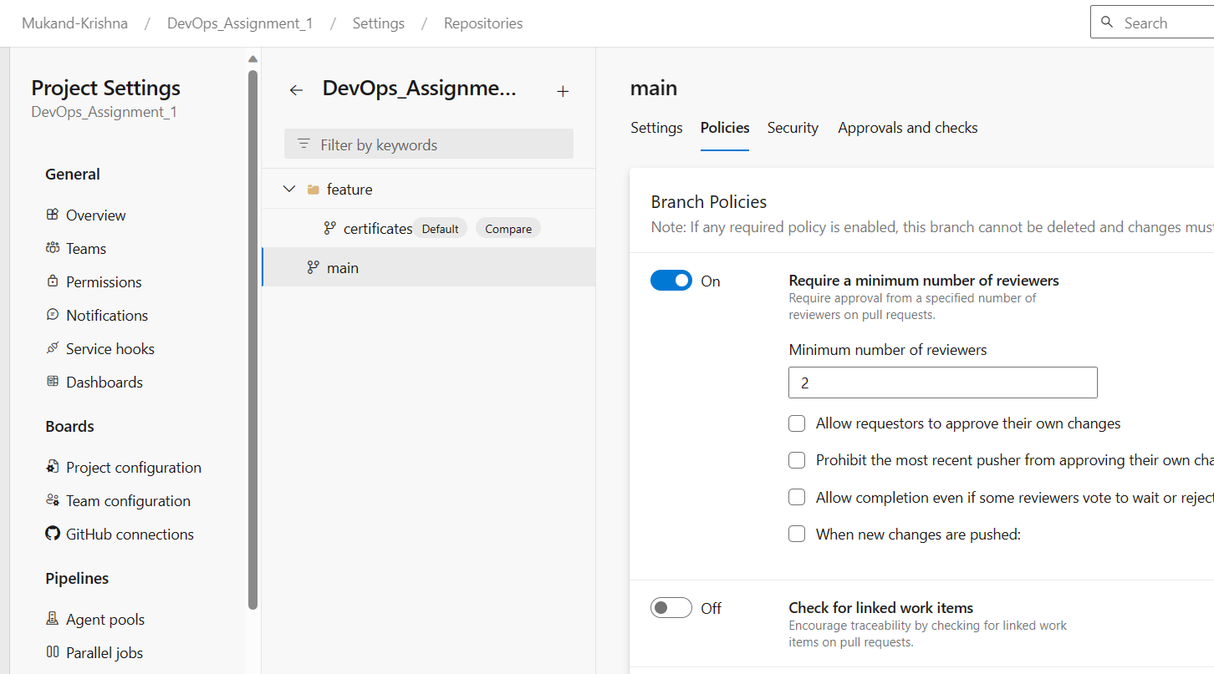

**On the Azure DevOps**:

**TASK # 5**

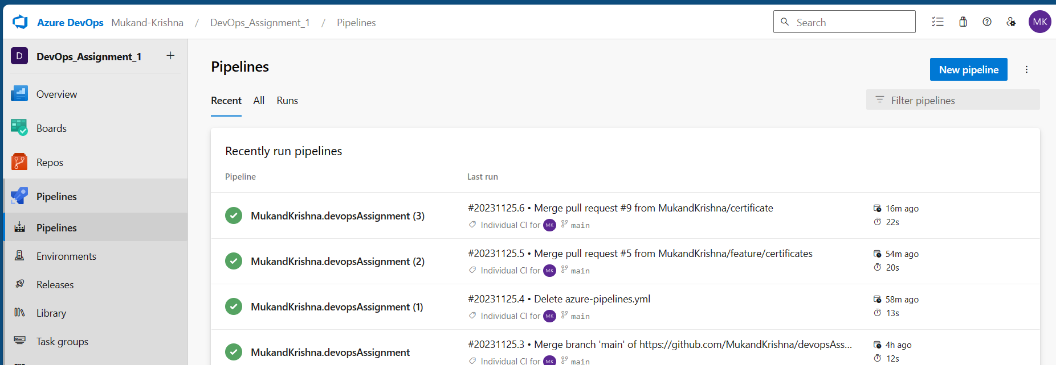

**TASK # 6**

**Added widgets: Pull request and Build History:**

